Wave Worksheet
In order to see sound wave more easily, scientists use a piece of equipment called a cathode ray oscilloscope to convert a longitudinal sound wave into a digital transverse wave.
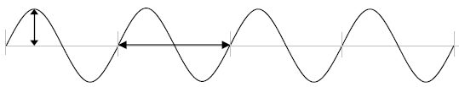
Frequency – The frequency of a wave is how many times it vibrates in one second. Frequency is measured in Hertz (Hz). The higher the frequency of a vibration, the higher the pitch of the sound that is produced.
Amplitude – The amplitude measures the energy of a transverse wave. It is measured from the resting position to the top of a crest or the bottom of a trough. The higher the amplitude, the louder the sound that is produced. The loudness of sounds is measured in Decibels (Db).
Wave 1 – Reference Sound Wave
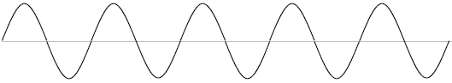
Frequency: __________

Compare each of the sound waves below to Wave 1. State whether each is higher or lower in frequency (pitch) and higher or lower in amplitude (volume).
Each sound wave is one second long.
Wave 2
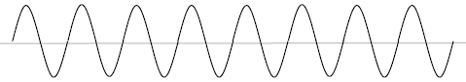
Frequency: __________ Pitch: __________ Amplitude: __________ Volume: __________

Wave 3
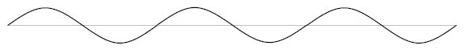
Frequency: __________ Pitch: __________ Amplitude: __________ Volume: __________
Wave 4
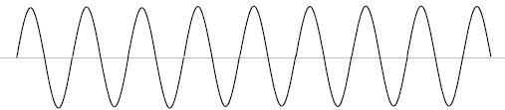
Frequency: __________ Pitch: __________ Amplitude: __________ Volume: __________

Wave 5
Frequency: __________ Pitch: __________ Amplitude: __________ Volume: __________

Wave 6
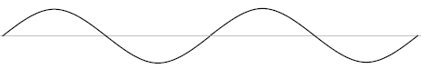
Frequency: __________ Pitch: __________ Amplitude: __________ Volume: __________
Wave 7
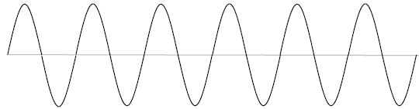
Frequency: __________ Pitch: __________ Amplitude: __________ Volume: __________

